Please let’s be mindful of the rubric

Model Built (B) 25 pts
A description of the model built is thoroughly developed with supporting details

Description of the Variables Included 25pts
A description of the variables included and why variables were left out is clearly provided and well developed.

Screenshots 25pts
Screenshots are present and include substantial detail.

Raw Software Files 10 pts
Raw software files are mostly complete and correct.

Thesis Development and Purpose 7 pts
Thesis is comprehensive and contains the essence of the paper. Thesis statement makes the purpose of the paper clear.

Argument Logic and Construction 8pts
Clear and convincing argument that presents a persuasive claim in a distinctive and compelling manner. All sources are

Mechanics of Writing (includes spelling, punctuation, grammar, language use) 5pts
Mechanics of Writing (includes spelling, punctuation, grammar, language use)

Paper Format (use of appropriate style for the major and assignment) 5pt
Paper Format (use of appropriate style for the major and assignment)

Paper Format (use of appropriate style for the major and assignment) 5pts
Paper Format (use of appropriate style for the major and assignment)

Create a draft outline describing your model and addressing the following:
- Demonstrate your application of the data analysis process by specifying which models you built and indicate why this best addresses the business problem.
Model 1
- K-Means
  - Helps us put observersion into clusters or group with the nearest mean
  - We had 3 clusters, low number of patients, high length of stay and high charges
  - Cluster 1 shows medium number of patients, length of stay, professional fee, lab cost and charge as compared to cluster 2 and 3.
  - Cluster 2 has higher number of patients with short length of stay, low professional fees, medication cost, lab cost, and low total charges
  - Cluster 3 has the least number of patients and high charge with long length of stay, high professional,and lab cost

- The K-Means will help us to know how each of the various variables in the clusters affect the cost of heart disease treatment. For instance:
  - We will be able to know the groups each of the heart diseases belong to, and how each variable contributes to the total cost of treatment.
  - Heart failure without major complication or comorbidity (w mcc) to Cardiac arrest, unexplained w mcc belongs to cluster 1 with medium number of patients, length of stay, professional fee, lab and overall less charges as compared to cluster 2 and 3 with heart diseases with major complication or comorbidity
  - Cluster 3 contains the least number of patients with long length of stay, high facility, professional,and lab cost shows how addition of all these variables contributes to the total charges.
- By using K-means we are able to know how every independent variable in every category/cluster affect the charges
  - By putting observersion into clusters we are able to know how each of our independent variables affect cost of treatment the most in each cluster for each disease. For instance Cluster 2 has higher number of patients with short length of stay, low professional fees, medication cost, lab cost, and low total charges
Model 2:
- Linear Regression
  - With this modeling we are able to model our independent variables with our dependent variable and observe the relationship each independent variable has to the charges of heart disease treatment(dependent variable).
  - The model below represents the independent variables and depend variables that were used:
    - Dependent variable : Charge
    - Independent variables: number of patients, Age, Length of stay (days), Gender (Number of Male, Number of Female), Facility Fee, Professional Fee, medication cost, and lab Cost.

*** things to consider here
Partitioning the dataset into training and testing, running the Summary, correlation, looking at the p-values etc

- Description of the variables
  - Charges : total cost charged to patients for heart disease treatment
  - Number of patients: A count of number of patient treated of heart diseases
  - Length of Stay: The number of stay patients spend at the hospital for treatment
  - Facility fee: Amount charged by the hospital for the facility and the equipment used for treatment
  - Gender: number of male and female patients treated of heart diseases
  - Professional fee: Amount charged by the physicians/health worker for treating patients
  - Medication cost: The cost of medication used to treat the diseases
  - Lab cost: Charges incurred for various lab test for diagnosis and treatment of the disease

- What variables did you include or leave out and why?
Based on the run linear regression model. The first model was run in r including all independent variables and they showed the correlation with the dependent variable(charges). Some variables in the model had a p-value of more than 0.05 showing that they are not statistically significant to the dependent variable. These variables included number of patients, Age, Length of stay (days), Gender (Number of Male, Number of Female), Facility Fee, and lab Cost. Only the length of stay and the professional fee were shown to be significant and were the two variables that were kept

- Provide specific screenshots from the modeling software.

Figure 1: K-Means Cluster Plot
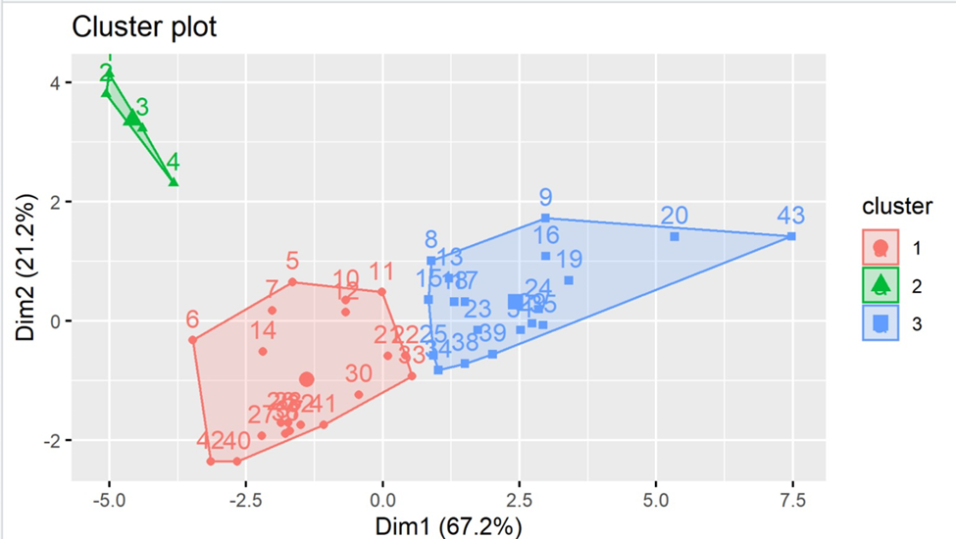

Figure 2: Optimal Number of Clusters- Elbow Method
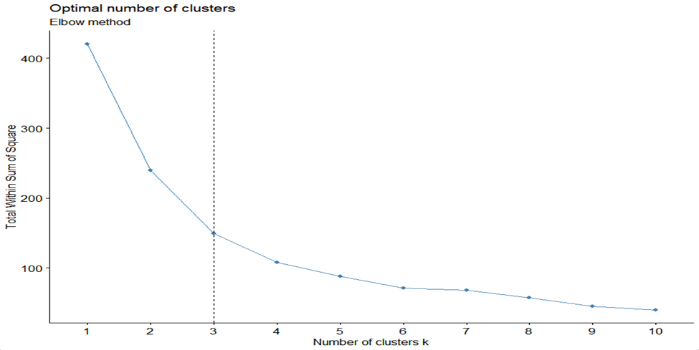

Figure 3: Number of clusters vs. gap statistic
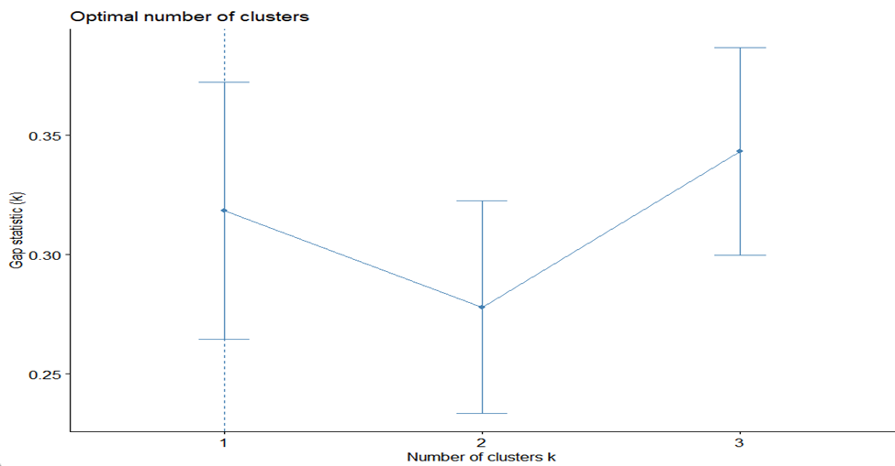

Figure 4: Optimal Number of Clusters- Silhouette method
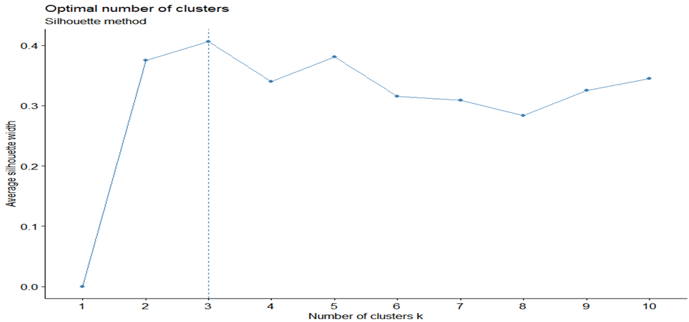

Table 1: Clustering Data Table
Figure 5: qq plot for each variable
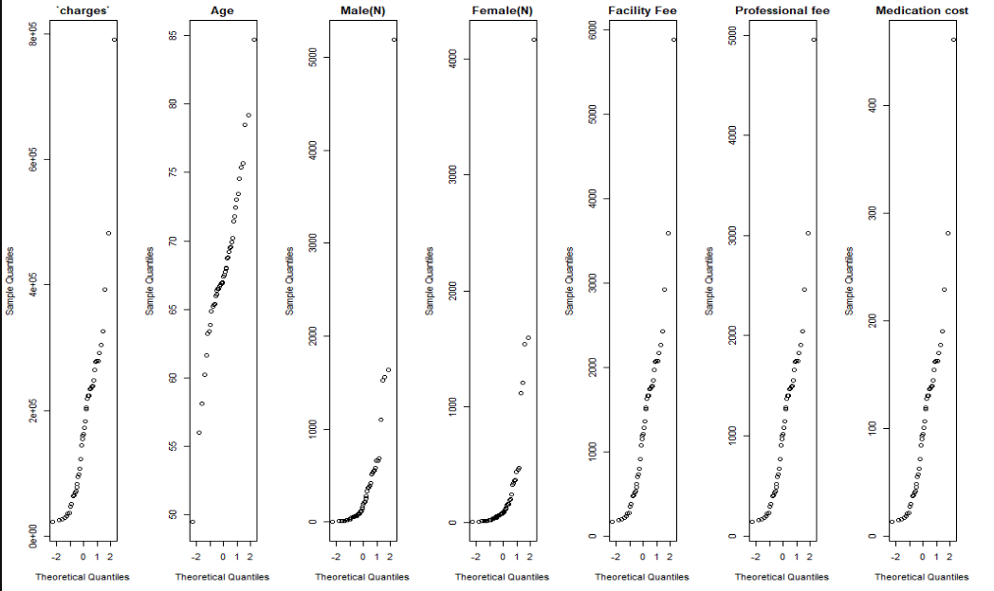
Figure 6: Histogram for each variable
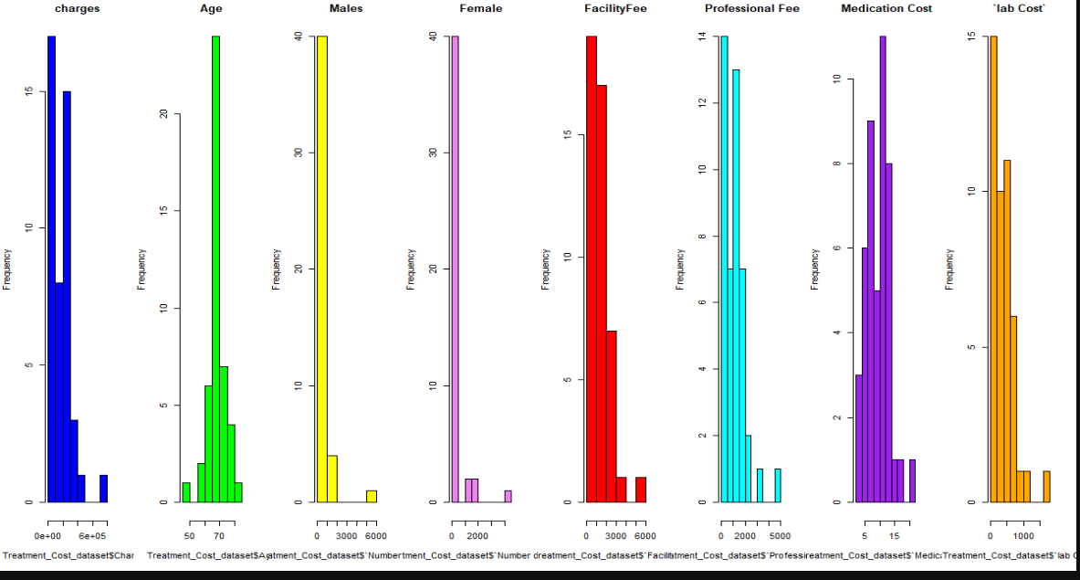
Figure 7: plott of all variables
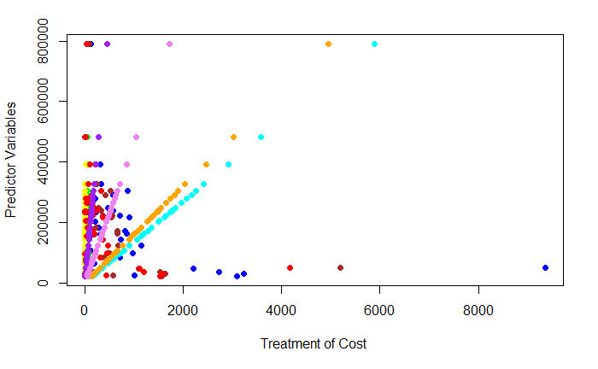
Figure 8: correlation coefficients between the variables
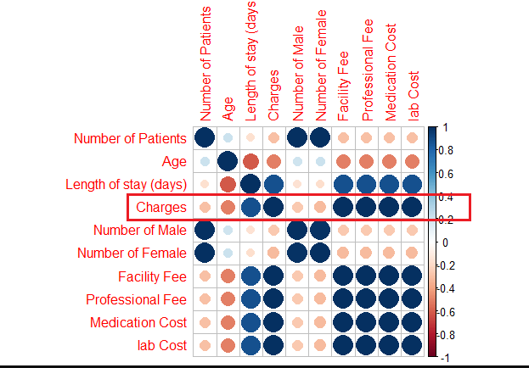
Figure 9: Linear regression model output with all variables
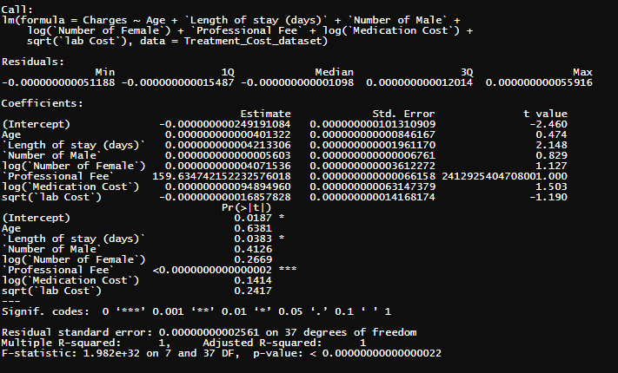
Figure 10: Linear regression model with significant variables 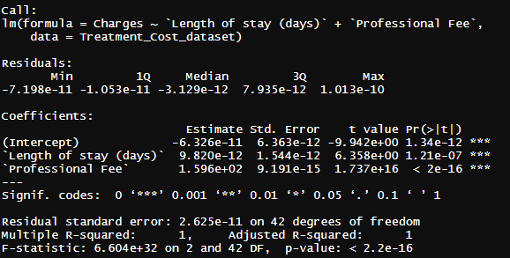

- Provide the raw software files that you used for this assignment.
- K means clustering R code
- Linear regression R code

